
SPARKLING WINE DATASET
Business Report


By: Shubhank katarey
(PGP-DSBA)

TIME SERIES FORECASTING - SPARKLING WINE DATASET

Problem Statement:

For this particular assignment, the data of different types of wine sales in the 20th century is to be analyzed. Both of these data are from the same company but of different wines. As an analyst in the ABC Estate Wines, you are tasked to analyze and forecast Wine Sales in the 20th century.

1. Read the data as an appropriate Time Series data and plot the data.

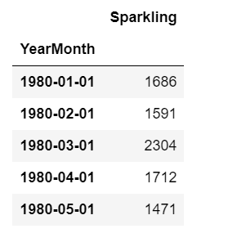

We can see that the dataset has loaded perfectly with YearMonth column as Index column.

Let’s look at the plot:

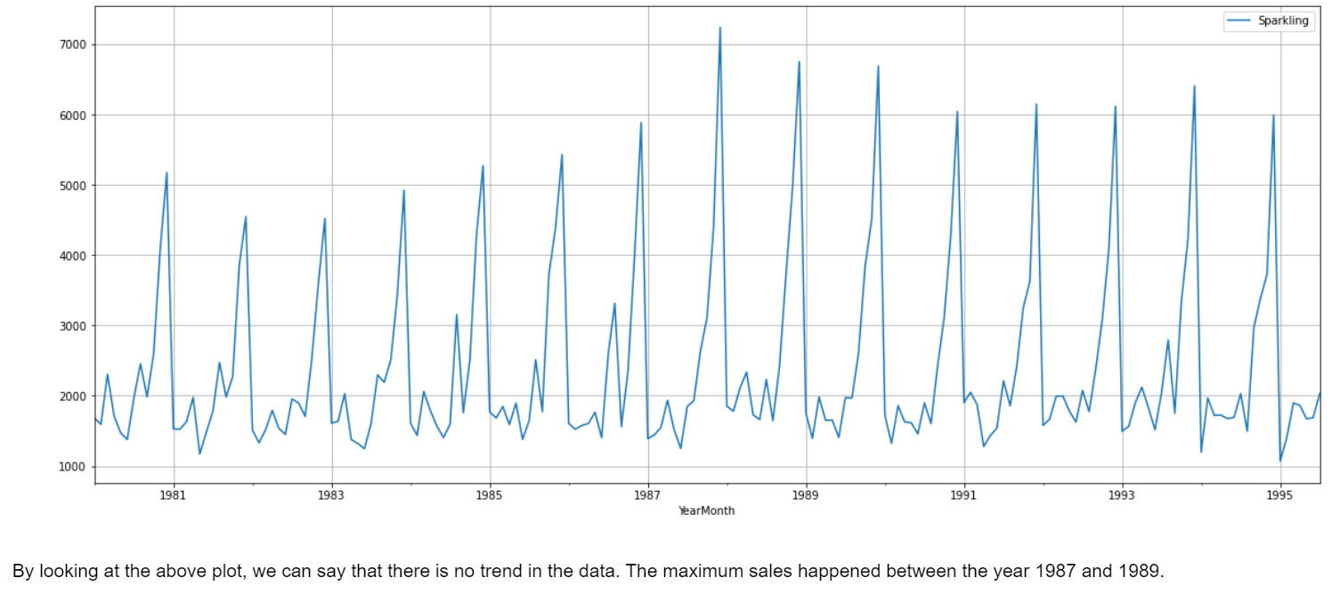

2. Perform appropriate Exploratory Data Analysis to understand the data and also perform decomposition.

Description or Summary of the dataset:

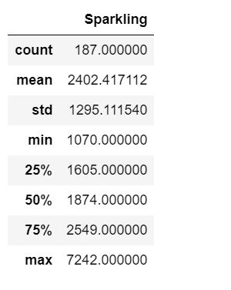

We can see that the maximum sales of the sparkling wine happened of 7242 and minimum sales of 1070.

Boxplot (Yearly):

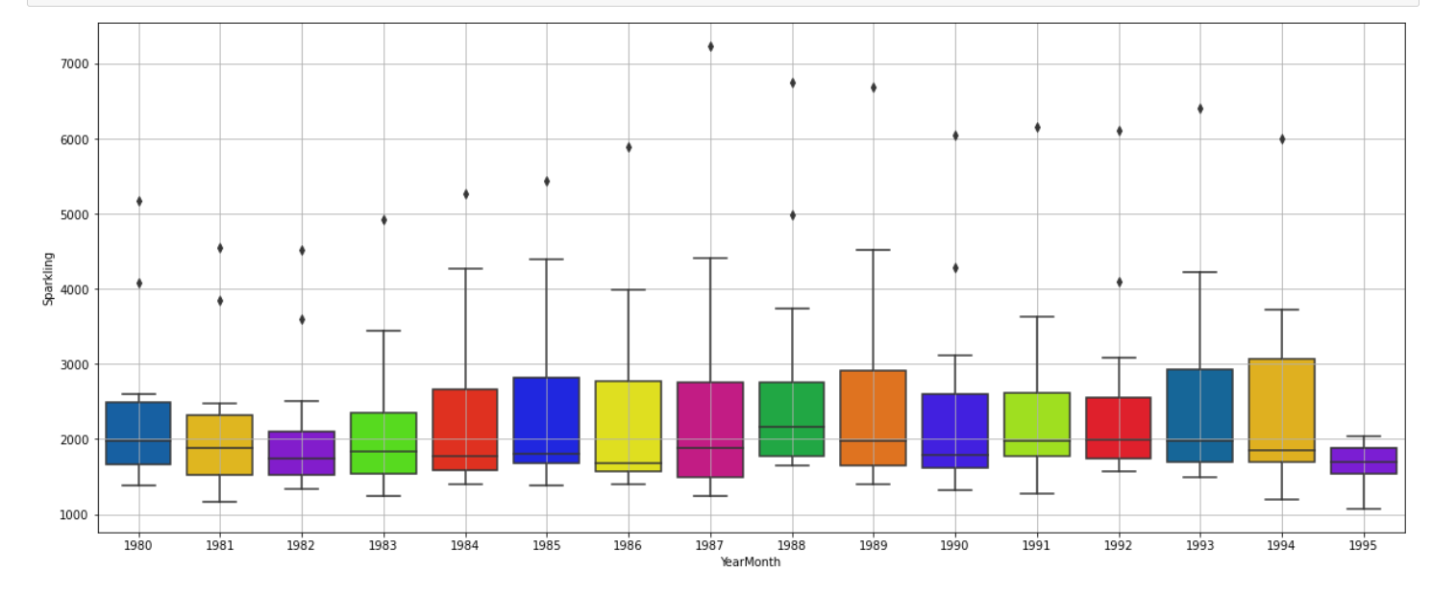

Boxplot (Monthly):

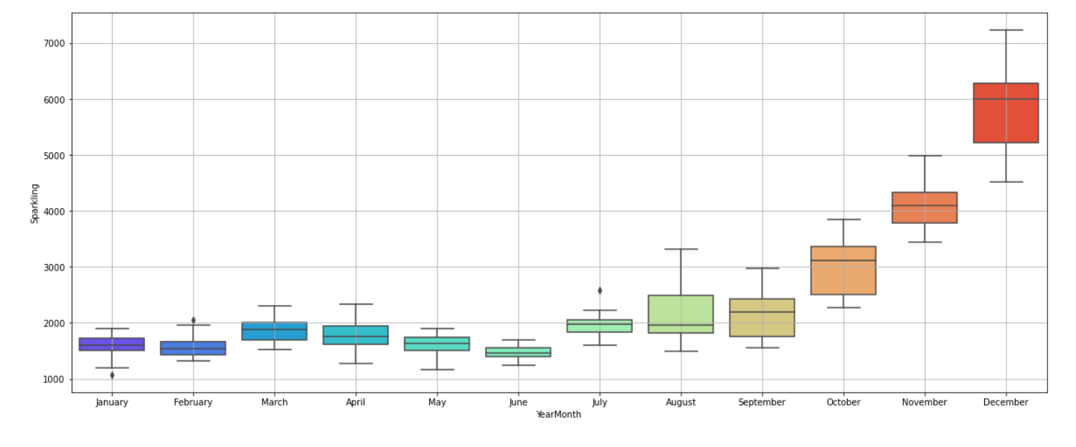

We can see that from January till June, the sales are not fluctuating too much but starting from July till December, we can see that sales increased. The maximum number of sales happened in the month of December and the lowest number of sales observed in the month of June.

Additive Decomposition:

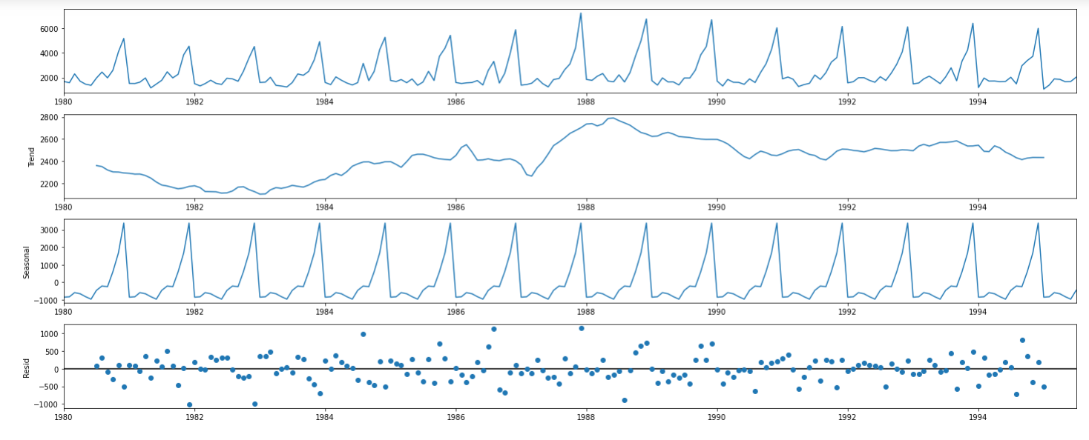

Multiplicative Decomposition:

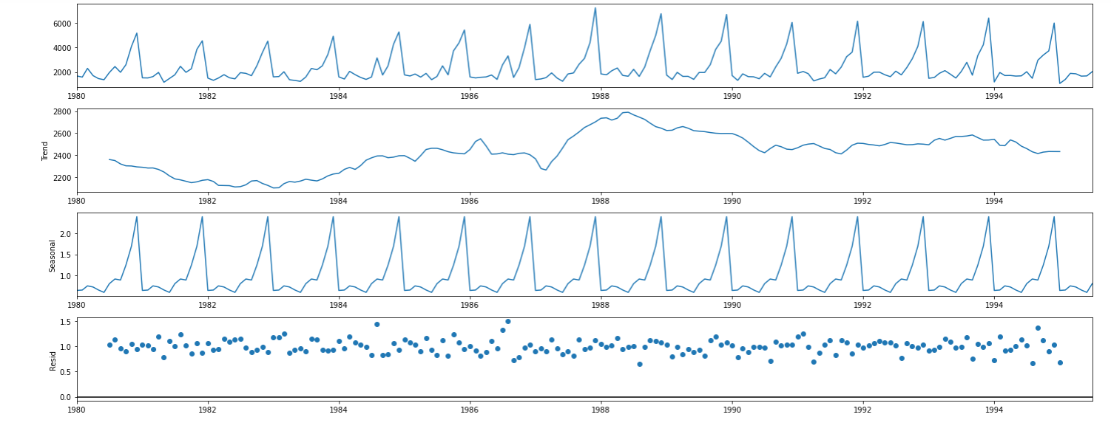

After observing the additive and multiplicative models, we can see that the trend and seasonality of both the models are same, and also we can see the patterns in residual also for both the models. So in such case, it is better to go with additive model.

For our further analysis, we will use additive model.

3. Split the data into training and test. The test data should start in 1991.

After split the data into train and test set, let’s look at the train and test sets separately.

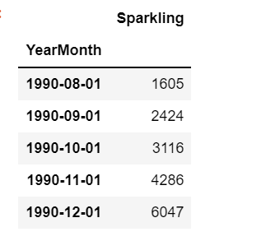

These are the last few records of the train set, which is showing up to year 1990.

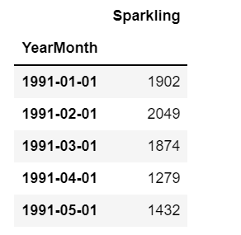

We can see that the last few rows of the train set is up to the 12th month of the year 1990 and from 1st month of the year 1991, the test set starts.

Let’s look at the plot of train and test set:

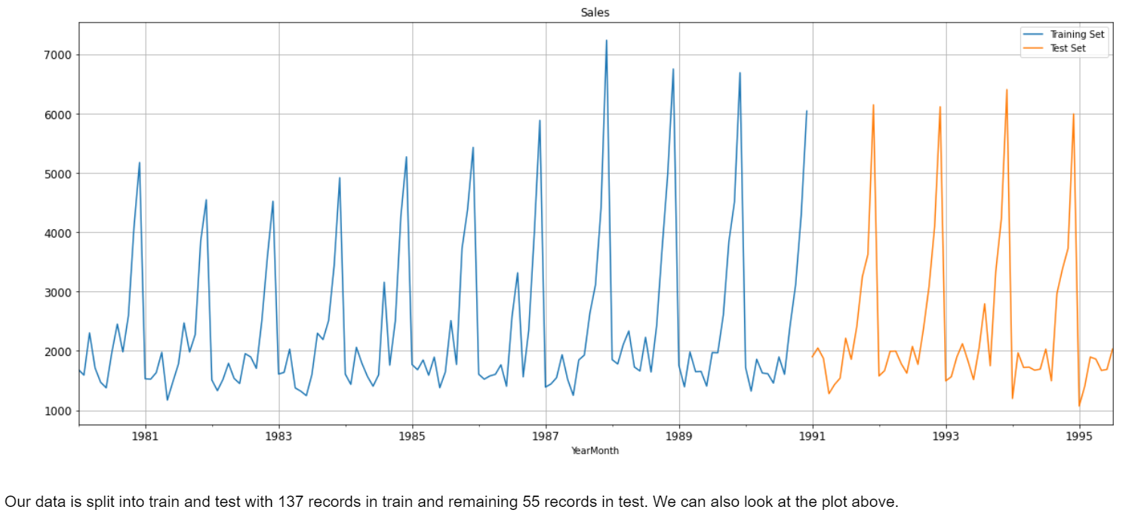

Our data is split into train and test with 137 records in train and remaining 55 records in test. We can also look at the plot above.

4. Build various exponential smoothing models on the training data and evaluate the model using RMSE on the test data. Other models such as regression, naïve forecast models, simple average models etc. should also be built on the training data and check the performance on the test data using RMSE.

Linear Regression Model:

Training time instance:

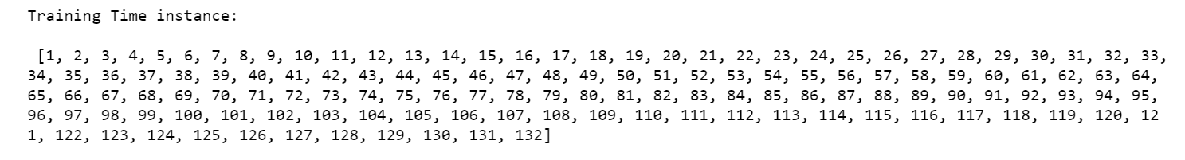

Testing time instance:

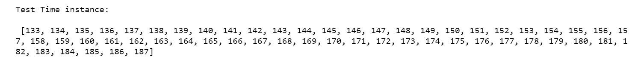

After splitting the train and test set into the given format, we have copied it into two variables and take it as train and test set for Linear Regression for further analysis.

Let’s have a look at both the data:

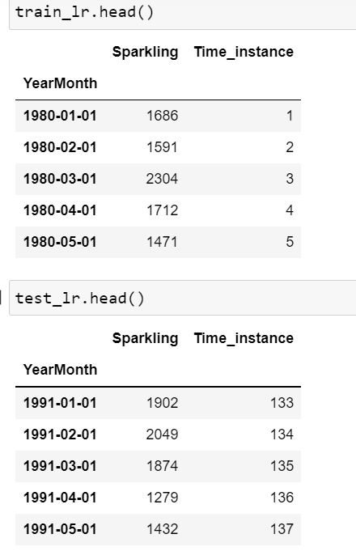

After fitting the train set into the Linear Regression Model and predict it on the test set, lets’ look at the Regression on time on test:

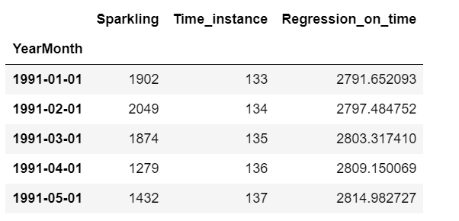

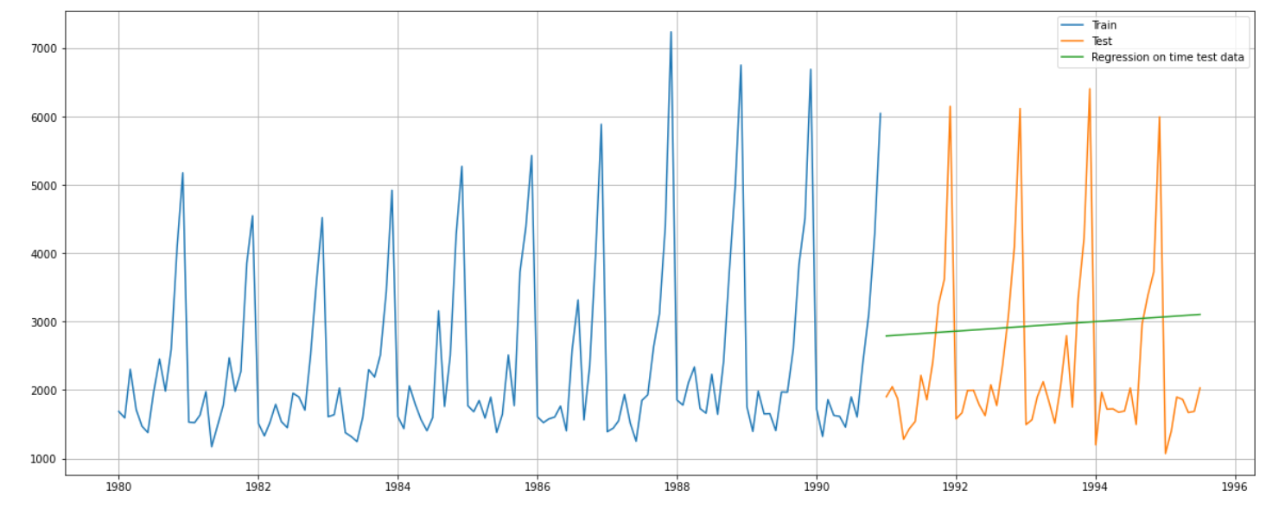

RMSE value for Regression on time forecast on test set:

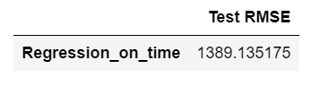

We have calculated the Root Mean Square Error on the test data for the Linear Regression Model. Now we will check RMSE for the other models and compare all the models to finalize the best model.

Naïve Model or Naïve Approach:

In Naive Model, we know that the prediction for tomorrow is the same as today and the prediction for day after tomorrow is tomorrow and since the prediction of tomorrow is same as today, therefore the prediction for day after tomorrow is also today. So, by using this approach we will further calculate the RMSE value.

This is train set head and tail for Naïve Model:

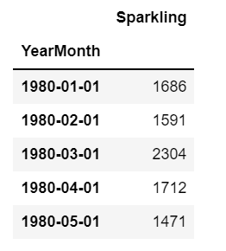

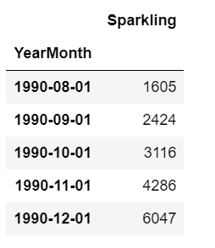

This is the test set head and tail for Naïve model:

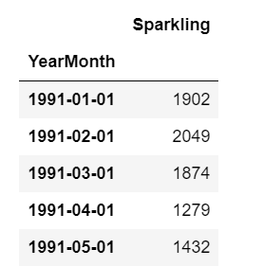

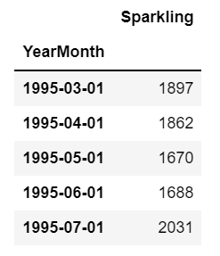

Plot for Naive Model forecast on Test data:

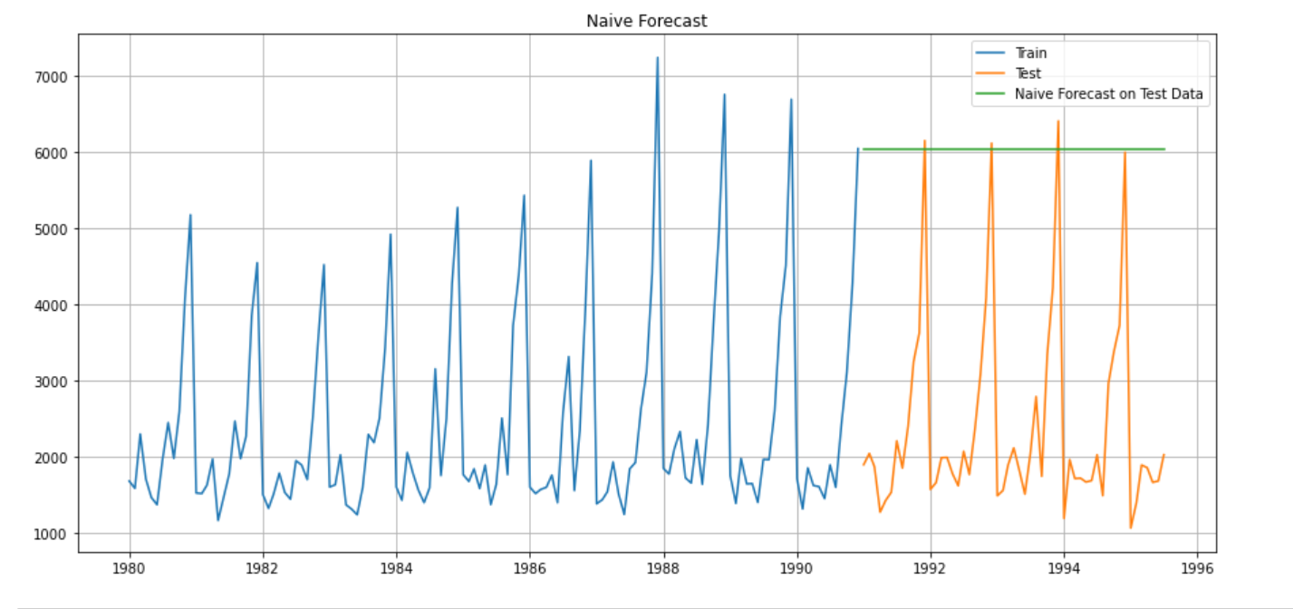

The blue line showing the train set plot, the orange line shows the test set plot and the green line above the test set showing the naïve model forecast on test data.

Let’s calculate RMSE on test data for Naïve model:

RMSE value for Naive Model on testing set is 3864.279

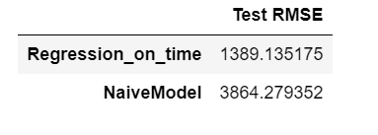

After calculating the RMSE on test set for Naive model, we can see the clear big difference in the values, that Naive model is giving very high error rate than the Linear Regression model. So at this point of time we can say that out of these two models, the Linear Regression is good. But before concluding and finalizing the end result, we need to look for the RMSE values of other models as well, like Simple Average, Moving Average, Simple Exponential etc.

Simple Average Model:

In Simple Average model we will take the average of the training values and then will forecast using it.

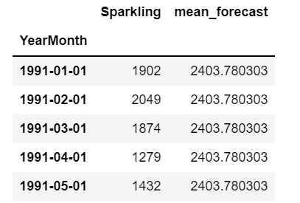

Mean forecast coming out for the training values is 2403.78. Now, let's plot it and have a look.

Plot for Simple Average Model:

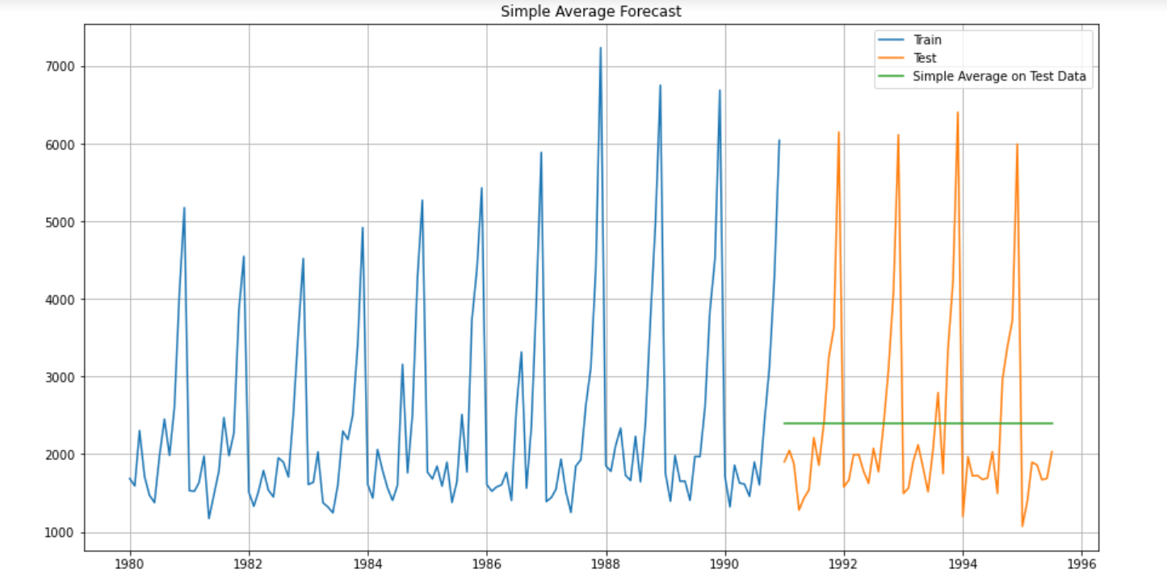

We can see the green line representing the mean value and we know that it is at 2403.78. Now let's evaluate the model.

Let’s calculate the RMSE value on Simple Average Model:

RMSE value for Simple Average Forecast on Test data is 1275.082

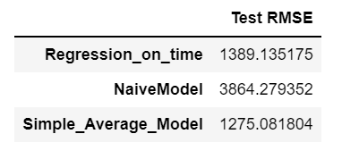

So now again, there we can see the major change in RMSE value, the error for the simple average model is coming down gradually and here it seems to be the winner from above all models. But still there are other models for which we need to calculate the RMSE values. Simple Average Model has the lowest RMSE value, which is 1275.08.

Moving Average Model:

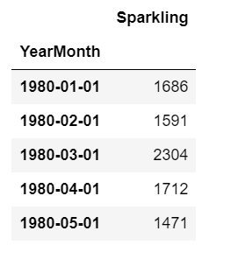

For this model, we need to calculate moving averages for different intervals. The best interval can be determined by the maximum accuracy with the minimum error.

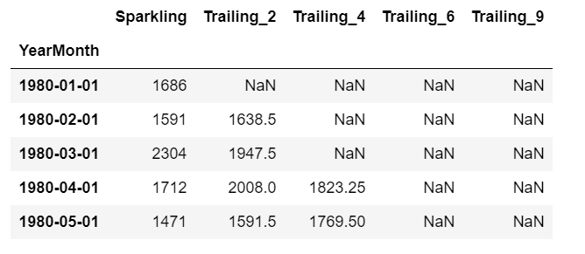

Plot for 2 point Moving Average, 4 point Moving Average, 6 point Moving Average and 9 point Moving Average on test data:

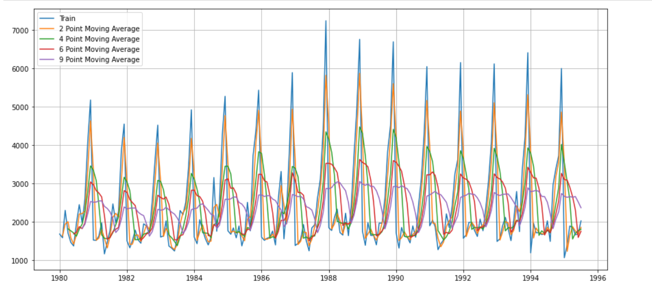

Plot for 2 point Moving Average, 4 point Moving Average, 6 point Moving Average and 9 point Moving Average on test data and train data.

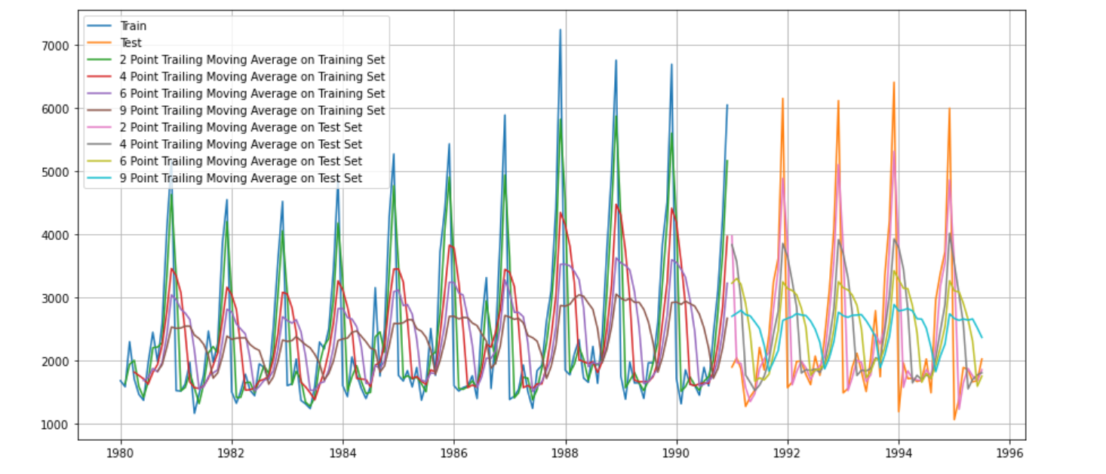

For 2 point Moving Average Model forecast on the Training Data, RMSE is 813.401

For 4 point Moving Average Model forecast on the Training Data, RMSE is 1156.590

For 6 point Moving Average Model forecast on the Training Data, RMSE is 1283.927

For 9 point Moving Average Model forecast on the Training Data, RMSE is 1346.278

We can clearly see that the RMSE for the trailing moving average model forecast for 2 point is best among all. The best RMSE is 813.401

Let’s calculate the RMSE value:

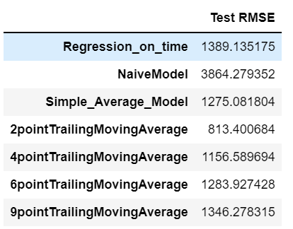

There is a clear view that 2 point trailing moving average is best model to go with for further analysis. But we have not yet build the simple exponential smoothing model, so before that we cannot finalize anything.

The lowest root mean square error for 2 point trailing moving average is coming out to be 813.400 is the best from all the remaining model that we have seen till now.

Simple Exponential Smoothing Model:

Simple Exponential Smoothing, is a time series forecasting method for univariate data without a trend or seasonality. It requires a single parameter, called alpha (a), also called the smoothing factor or smoothing coefficient.

This method is suitable for forecasting data with no clear trend or seasonal pattern.

SES is represented as: Ft+1=αYt+(1−α)Ft

Parameter α is called the smoothing constant and its value lies between 0 and 1. Since the model uses only one smoothing constant, it is called Single Exponential Smoothing.

Simple Exponential Smoothing class must be instantiated and passed the training data.

The fit () function is then called providing the fit configuration, the alpha value, smoothing_level. If this is omitted or set to ‘none’, the model will automatically optimize the value.

Let’s check the best parameters using auto fit:

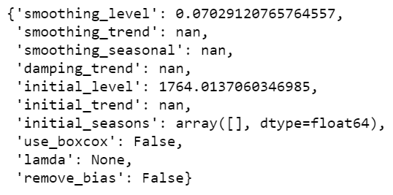

We got the smoothing level of 0.070. Now using the fitted model on the training set to forecast on the test set.

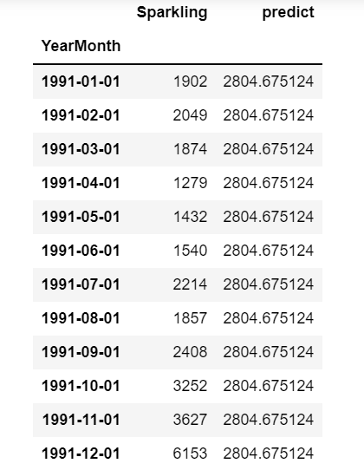

…..

Plot of Simple Exponential Smoothing model on test data forecast with alpha value of 0.070:

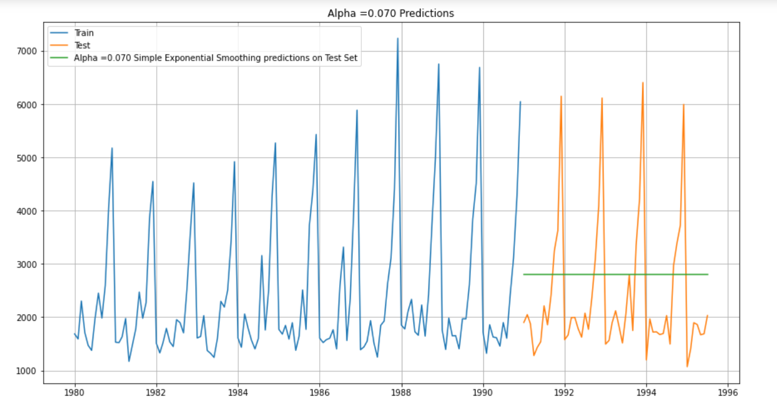

Let’s calculate the RMSE value on test data to see how well the model is performing on test set:

RMSE value for alpha value 0.070 Simple Exponential Smoothing Model forecast on the Test Data is 1338.008

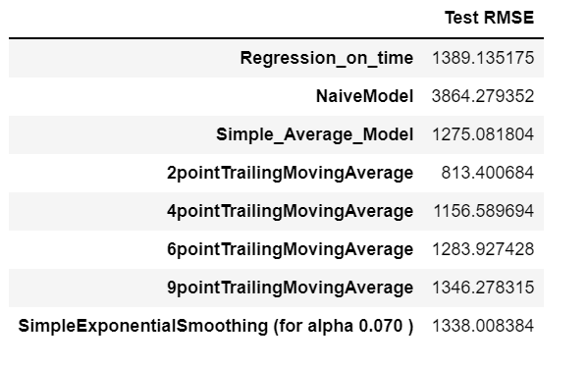

After comparing RMSE values of all models till now, we still got the best RMSE value of 2 point trailing Moving Average.

After applying auto fit, we got the below parameters:

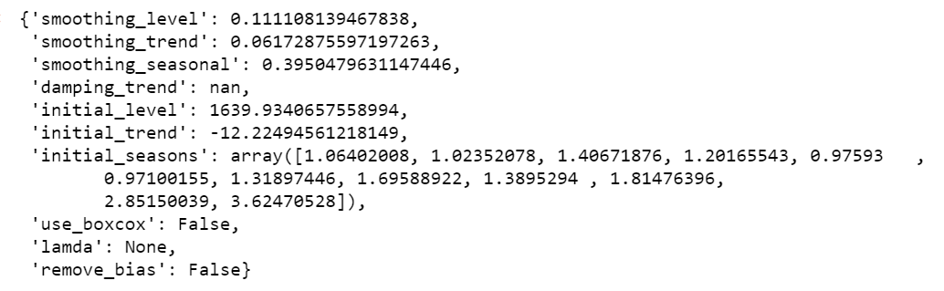

We got the alpha, beta and gamma values.

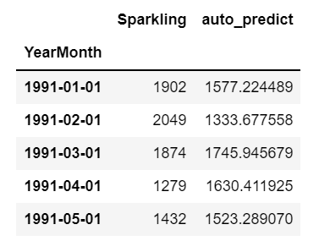

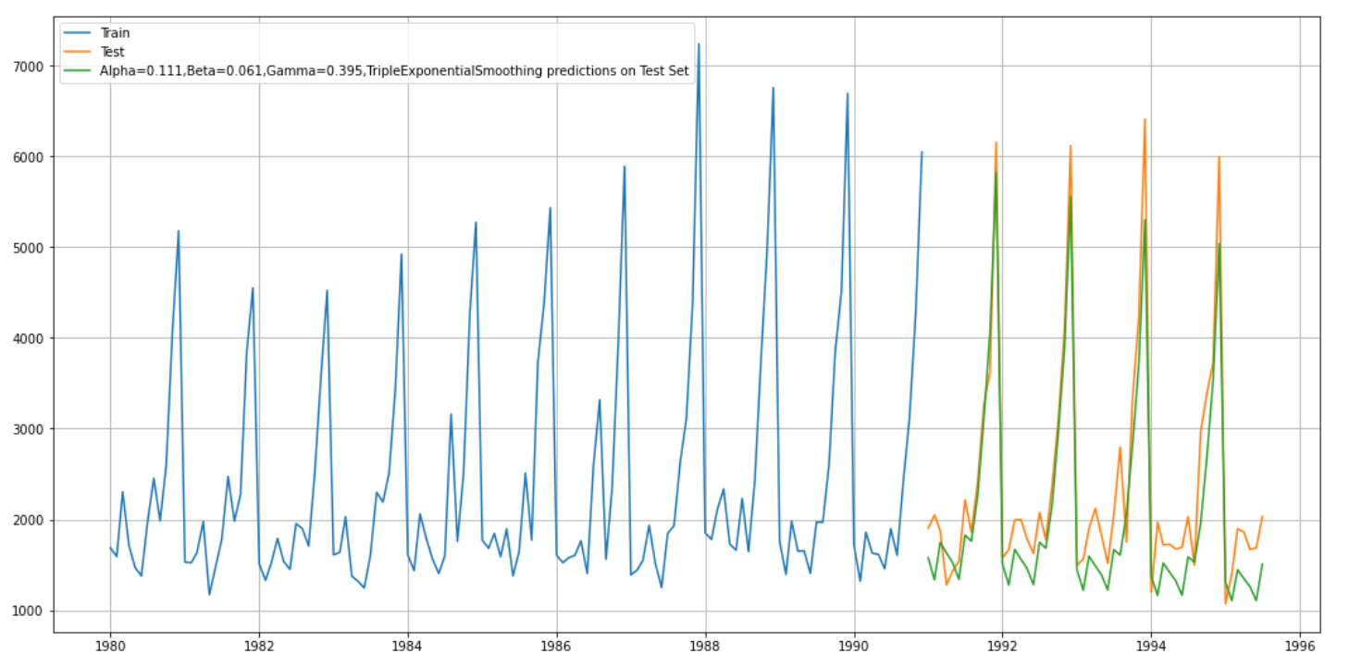

Calculating RMSE:

RMSE for the Triple Exponential Smoothing Model forecast for the given values on the Test Data is 469.768

Comparing RMSE values of all the models:

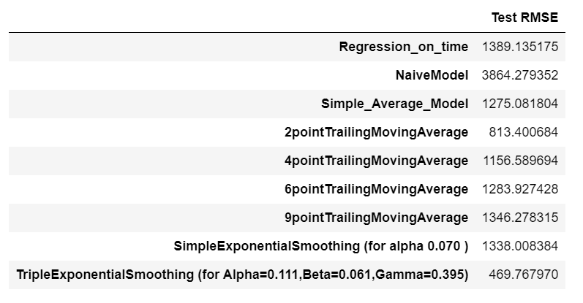

We found out the lowest RMSE value on test data by using Triple Exponential Smoothing with the value of alpha (0.111), value of beta (0.061) and with the value of gamma (0.395). So now we can see till now the best model amongst all is Triple Exponential Smoothing model.

5. Check for the stationarity of the data on which the model is being built on using appropriate statistical tests and also mention the hypothesis for the statistical test. If the data is found to be non-stationary, take appropriate steps to make it stationary. Check the new data for stationarity and comment. Note: Stationarity should be checked at alpha = 0.05.

To check the stationarity of the data, first we need to perform Dickey Fuller test

Dickey Fuller Test:

For this test, we need to make null and alternate hypothesis:

We will take the Null Hypothesis 𝐻0H0 as - Series is not Stationary and Alternative Hypothesis 𝐻1H1 as - Series is Stationary.

Since we have to proof that data is stationary and also we will take steps to make the data stationary.

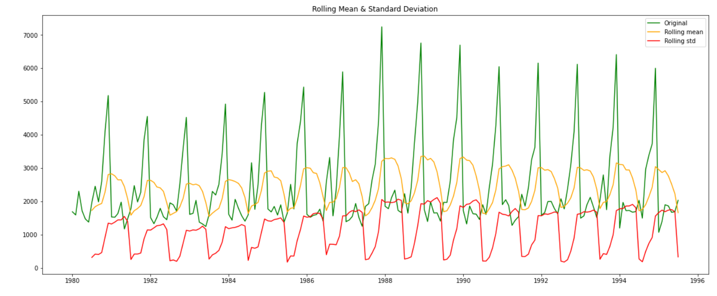

Time series does not seems to be stationary at 5% significant level.

We have to check again with the difference of order 1.

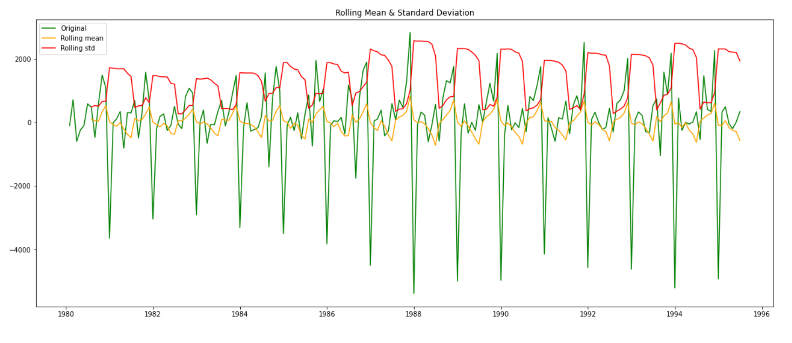

Now the series is stationary.

6. Build an automated version of the ARIMA/SARIMA model in which the parameters are selected using the lowest akaike Information Criteria (AIC) on the training data and evaluate this model on the test data using RMSE.

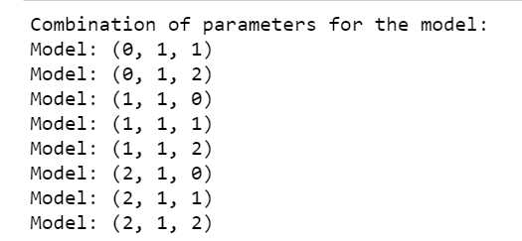

Below is the ARIMA model values with all the AIC values:

ARIMA (0, 1, 0) - AIC: 2269.582796371201

ARIMA (0, 1, 1) - AIC: 2264.906438611577

ARIMA (0, 1, 2) - AIC: 2232.78309768405

ARIMA (1, 1, 0) - AIC: 2268.5280607650034

ARIMA (1, 1, 1) - AIC: 2235.0139453493175

ARIMA (1, 1, 2) - AIC: 2233.597647121205

ARIMA (2, 1, 0) - AIC: 2262.035600155025

ARIMA (2, 1, 1) - AIC: 2232.3604899121387

ARIMA (2, 1, 2) - AIC: 2210.6260491378257

ARIMA model results:

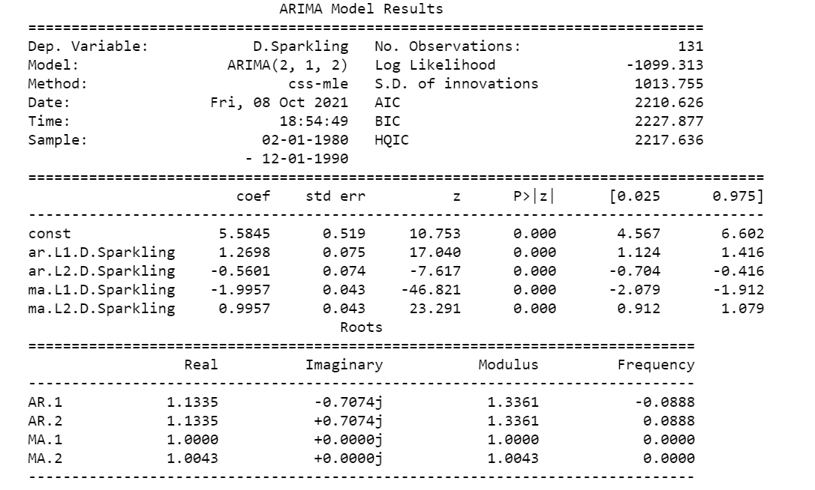

RMSE value on test data for ARIMA model: 1374.0370092580251

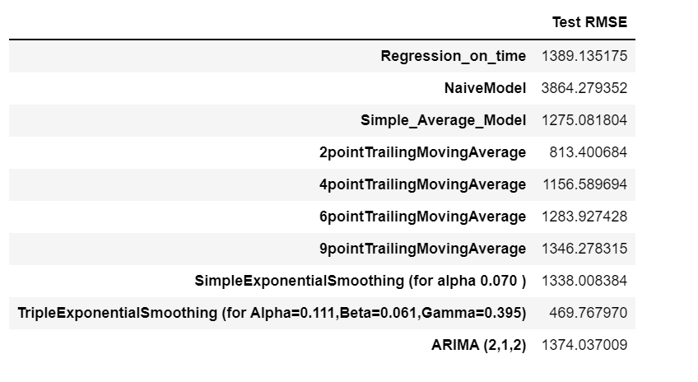

ARIMA model did not give the lowest RMSE value, so still the best model is Triple Exponential Smoothing model with lowest RMSE of 469.76

Automated SARIMA model:

Combinations of parameter for the SARIMA model:

Model: (0, 1, 1)(0, 0, 1, 12)

Model: (0, 1, 2)(0, 0, 2, 12)

Model: (1, 1, 0)(1, 0, 0, 12)

Model: (1, 1, 1)(1, 0, 1, 12)

Model: (1, 1, 2)(1, 0, 2, 12)

Model: (2, 1, 0)(2, 0, 0, 12)

Model: (2, 1, 1)(2, 0, 1, 12)

Model: (2, 1, 2)(2, 0, 2, 12)

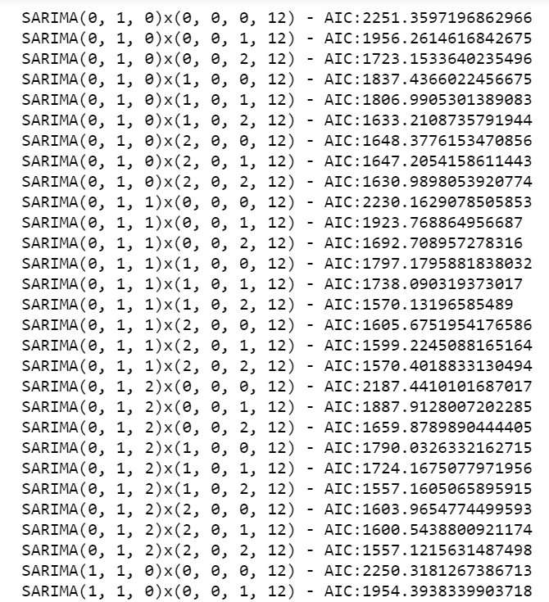

…..

SARIMA model with AIC values.

Top 5 lowest values of AIC with best parameters are:

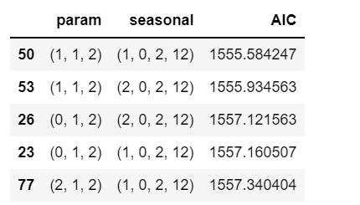

SARIMAX results:

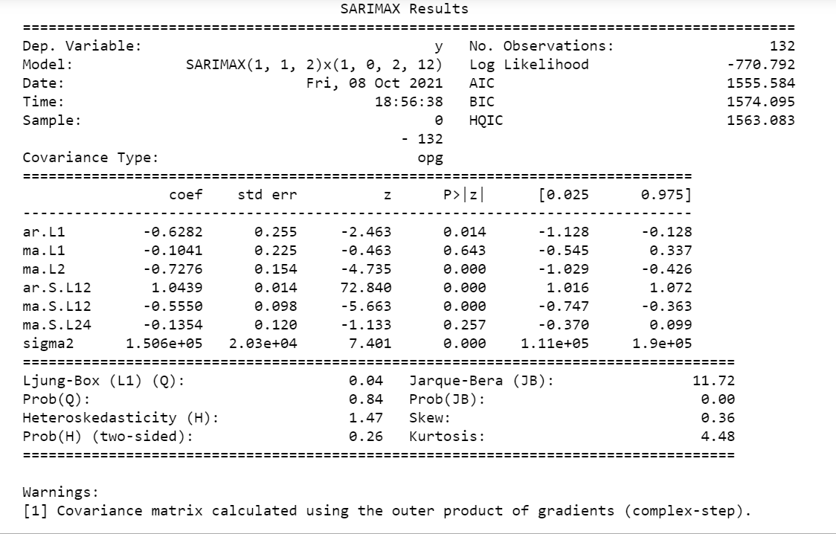

Let’s take a look at plots for Diagnostics of auto SARIMA model:

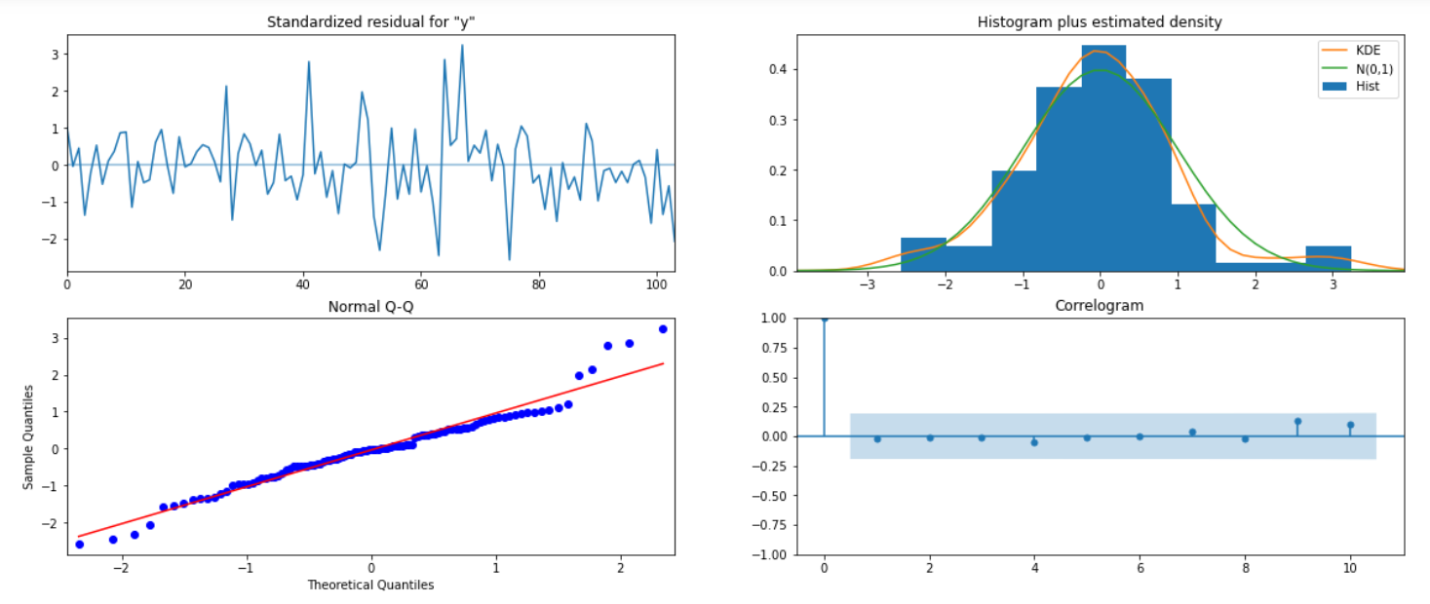

Prediction on test data:

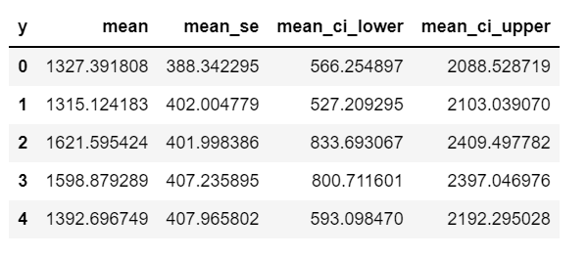

RMSE value on test data: 528.6126533320019

Comparing all the RMSE values till now:

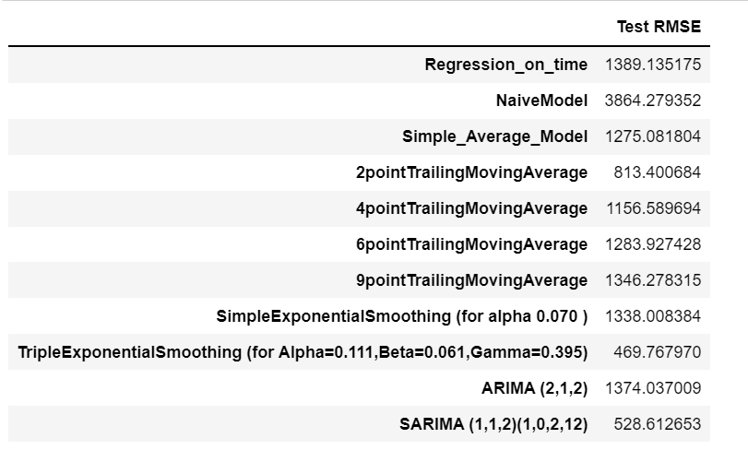

Till now the Triple Exponential Smoothing (for Alpha=0.111, Beta=0.061, Gamma=0.395) has the best RMSE value that is 469.767970

7. Build ARIMA/SARIMA models based on the cut-off points of ACF and PACF on the training data and evaluate this model on the test data using RMSE.

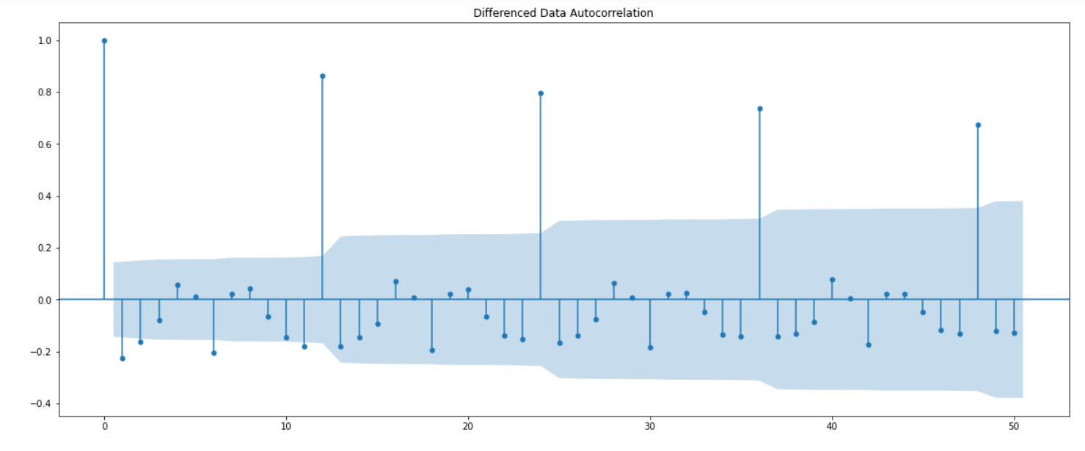

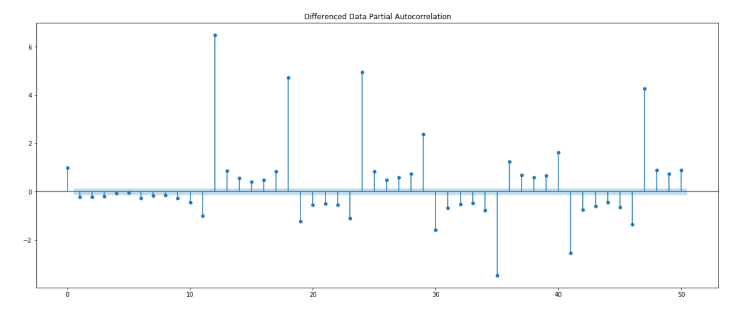

PACF cut offs point at lag 3 and ACF cut offs point at lag 2

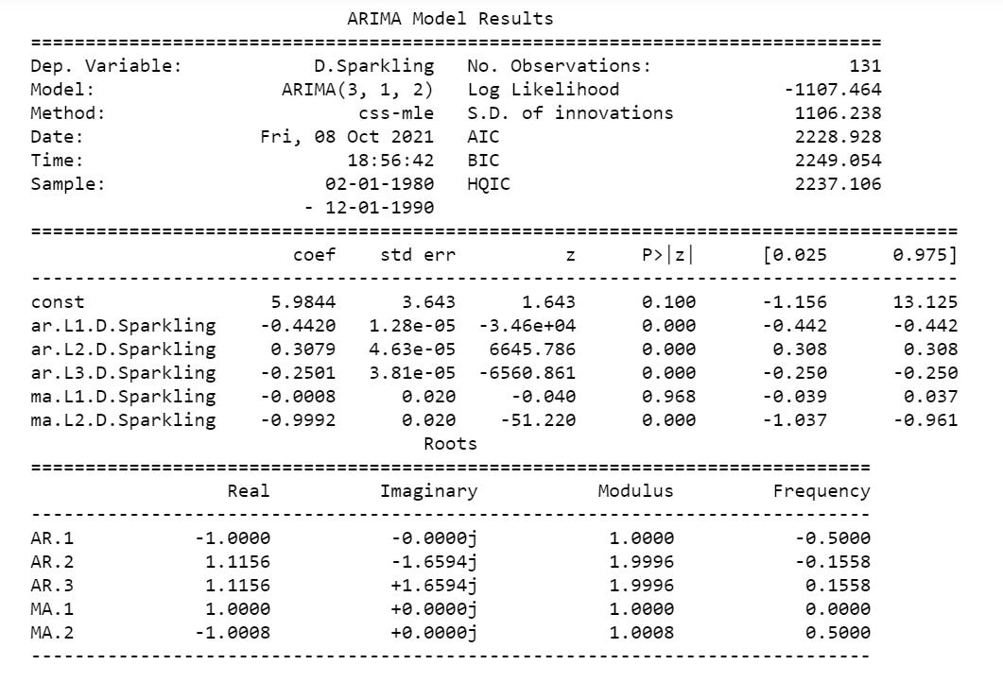

RMSE value on test data: 1379.0491231340152

Comparison between all the values of RMSE:

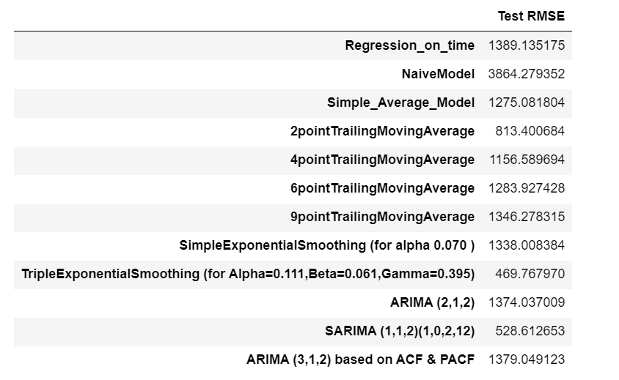

Plot at the differencing of 6:

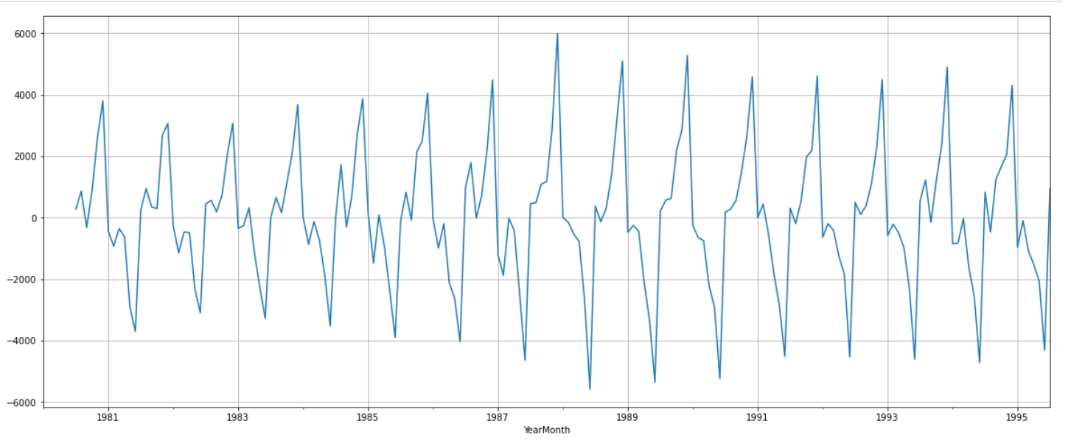

Again checking Stationarity using stationarity test with rolling mean and standard deviation:

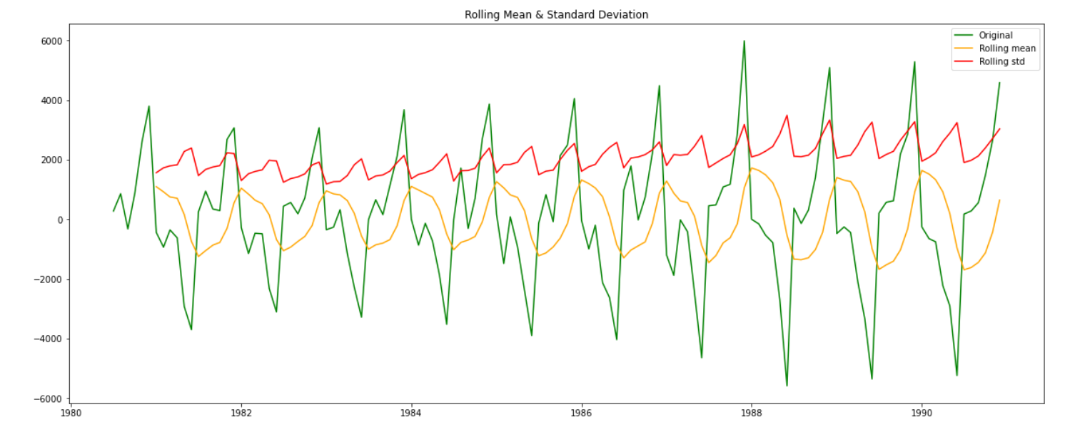

Auto correlation (ACF):

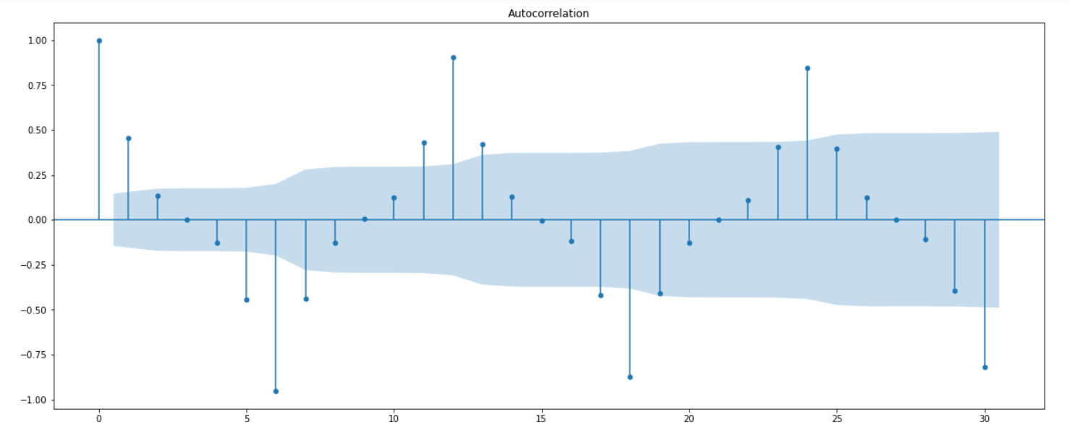

Partial Auto correlation:

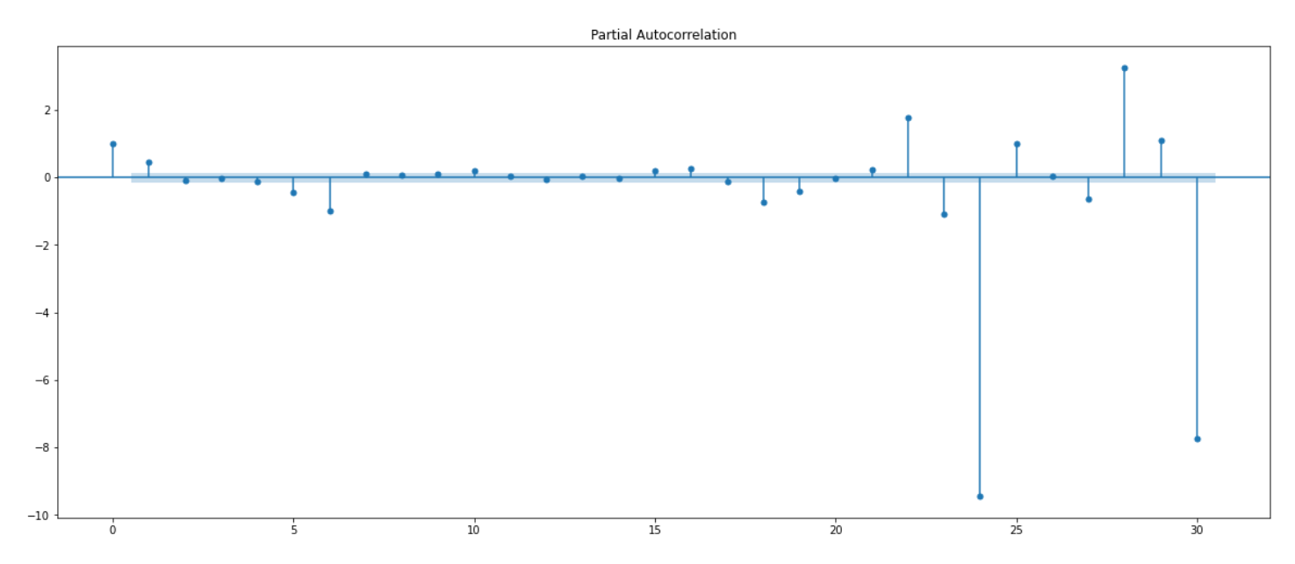

Now, both the ACF and PACF plots have the cut off at 1.

Alpha value at 0.05.

We will check the ACF and PACF plots at a multiple of 6, because seasonal period is 6.

SARIMAX results:

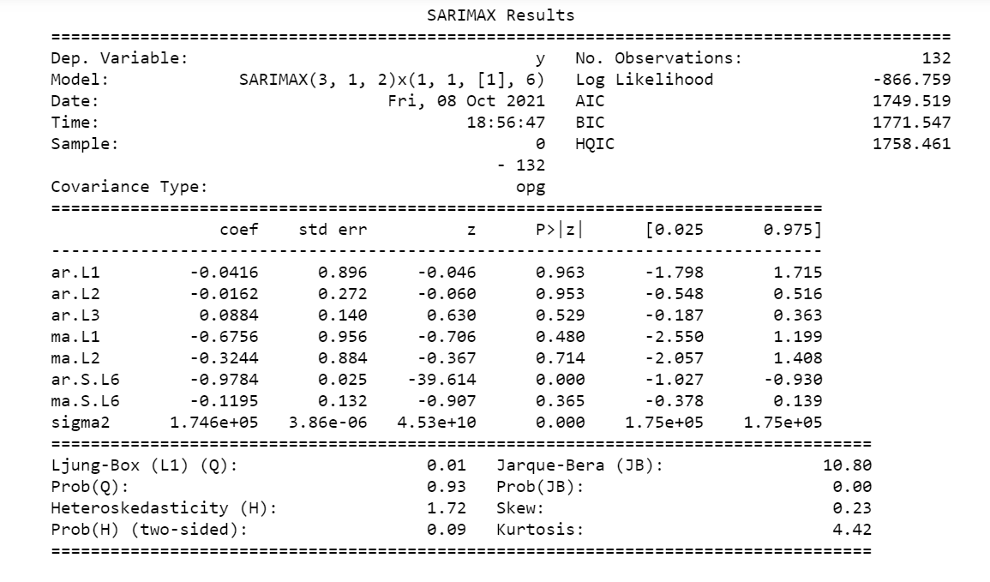

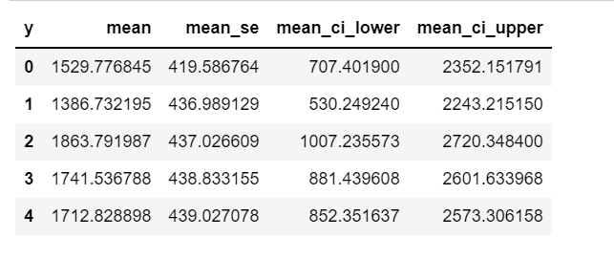

RMSE values: 329.88649987548496

Comparing all the RMSE values:

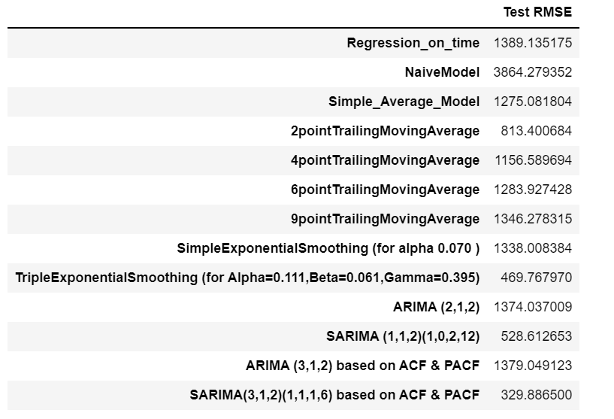

8. Build a table with all the models built along with their corresponding parameters and the respective RMSE values on the test data.

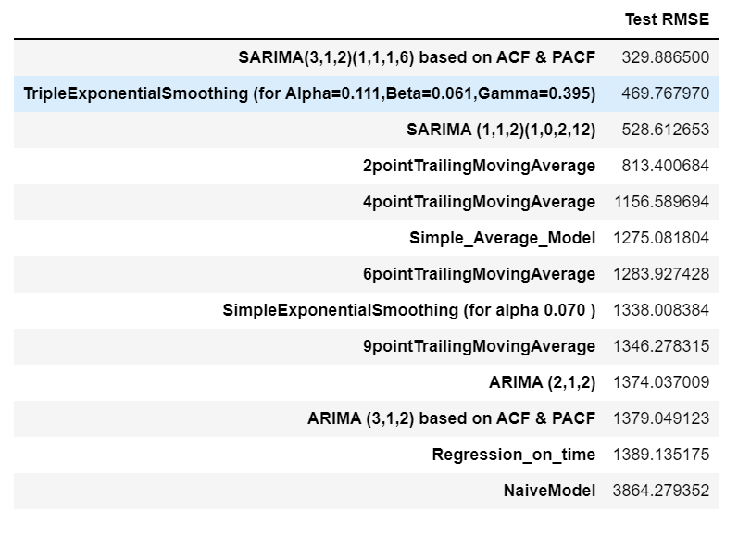

We can see that SARIMA model is best model with the lowest RMSE value of 329.88

9. Based on the model-building exercise, build the most optimum model(s) on the complete data and predict 12 months into the future with appropriate confidence intervals/bands.

The best optimum model that we have seen is the SARIMAX model. Applying it on whole dataset.

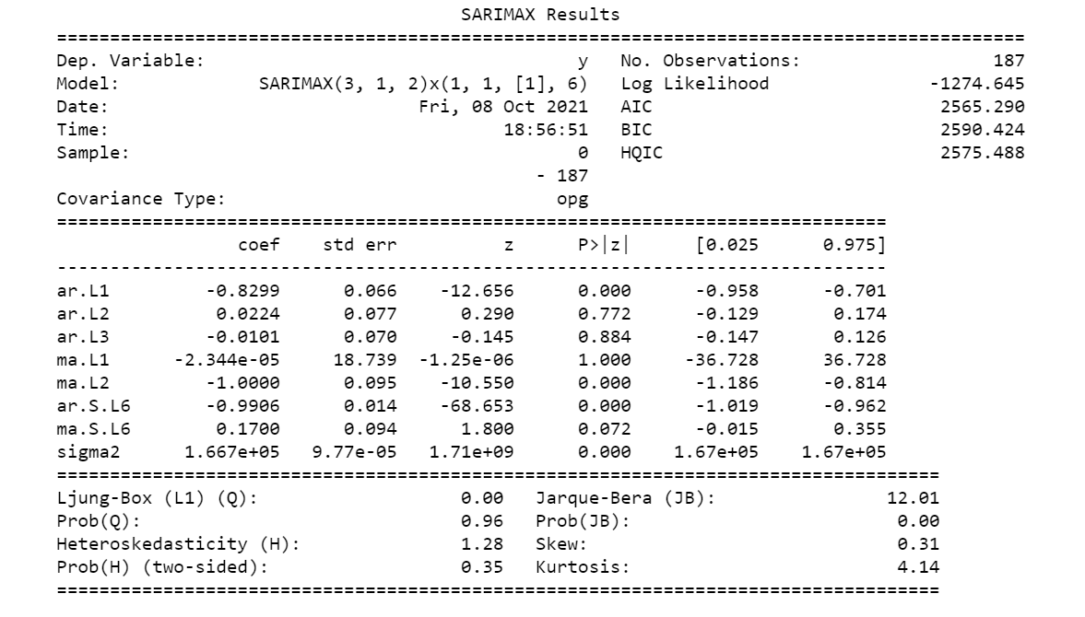

Let’s look at the plots of diagnostics of SARIMAX model:

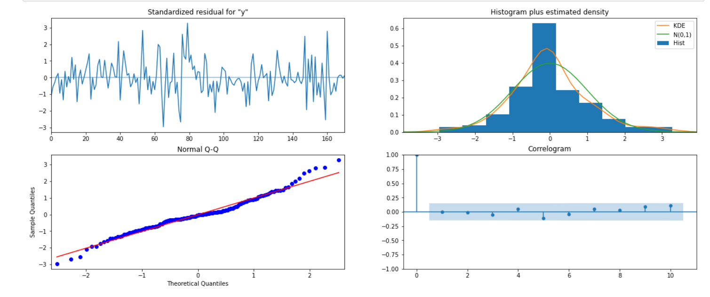

RMSE of the best optimum model on whole dataset is: 571.8691917375559

The below plot shows us the graph of observed pattern from 1981 till 1985 and forecast pattern after 1995.

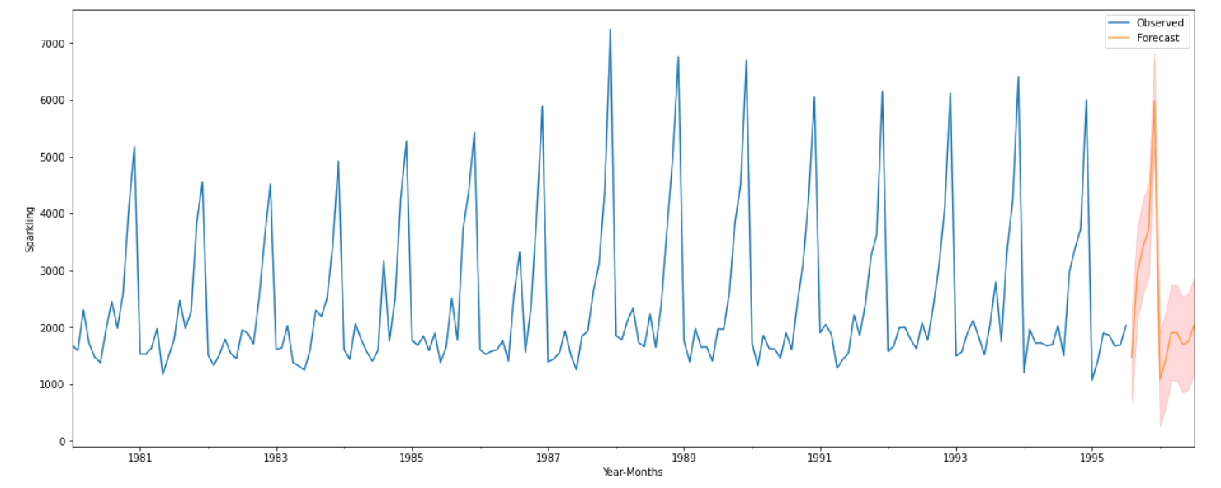

10. Comment on the model thus built and report your findings and suggest the measures that the company should be taking for future sales.

Some Measures that company need to take care of in future:

We have observed the highest Sales happened in the year 1987, and the lowest sales observed in the year 1995.
From the decomposition plot, we saw that the trend and seasonality are present in the dataset.
We have analyzed from boxplot (monthly plot) that sales has been increased from month of September to month of December.
We have built various models and tested on test data and also calculated RMSE values on test data to predict the forecast for next 12 months or more.
We have also observed that the original dataset has some seasonality pattern.
Found out that SARIMA has the lowest RMSE value.
So the same model later was applied on full data.
On the basis of final and most optimum model, the sales for next 12 month is predicted with confidence interval.
Company should keep its focus on reserved stock during the peak time, and in January, the sales recorded the lowest.
This is due to the fact that the December month usually observe more number of sales because of the year end and festive season phase.
For the positive side, company should maintain its production on the basis of median values which is around to 2000.
By doing so, company can fulfill the demands of the customers during the peak time and that also without any additional cost and any extra workers in the factory.
If we are able to take these above steps carefully then definitely our sales of the Rose wine would be more in upcoming future.

_______________________THE END_______________________________

